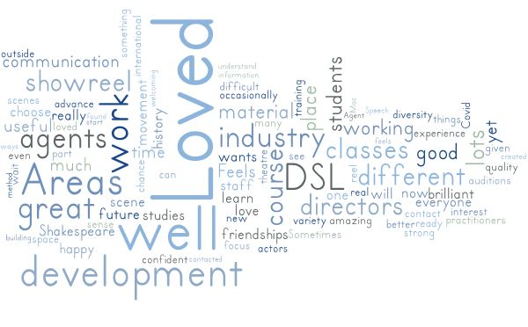
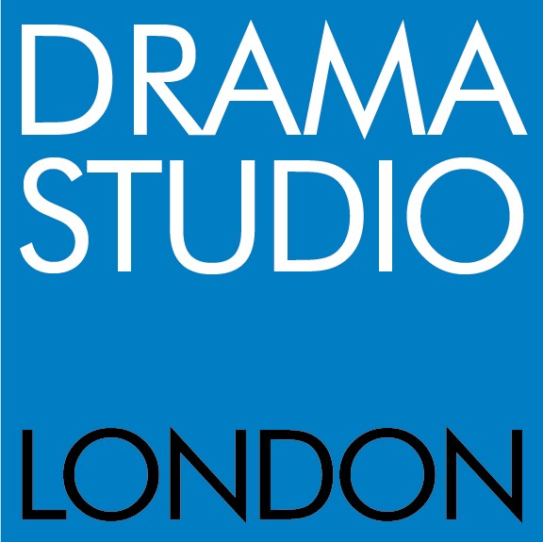

ABOUT DSL

Drama Studio London, established over 50 years ago, is renowned for delivering world-class training for the profession by the profession. The ethos underpinning learning design across all the courses integrates core approaches to classic conservatoire model training with a contemporary focus on the evolving skillsets, expectations and challenges required of the emerging professional actor in the 21st century performance industries.

DSL currently offers the following suite of courses:

MFA in Professional Acting (2 year), awarded by the University of West London. The MFA provides advanced actor training for postgraduates, alongside a practice research project focused on developing original performance, and including two short form international residencies.

BA (Hons) in Professional Acting (3 year) awarded by University of West London. This 3-year course maintains the integrity of the vocational, practice-based training whilst ensuring the academic rigour required by a degree.

PGDIP/ MA in Professional Acting (1 year) awarded by University of West London. This 1-year course a offers an intensive training route into the acting profession for postgraduates.

We also offer part-time and short courses throughout the year for aspiring actors and writers.
DSL is a founding partner of the Federation of Drama Schools, and is accredited by the CDMT and inspected by Ofsted.
The student body numbers in total around 180 students. Teaching is primarily delivered at sites across Ealing including Grange Court, DSL’s principal site. DSL values the individual attention that comparatively small class sizes and year groups can offer students.
DSL is committed to valuing and fostering an equal, diverse and inclusive learning community, where considerations of widening participation and representation across all staff and students inform our activities and strategies, shape our processes and practices and centralise these values as intrinsic to the ethos and success of the institution. We welcome applications from the Global majority, those with disabilities and from other under -represented groups.
.

APPLICATION PROCESS FOR

SUBJECT LEAD AUDIO

FIRST ROUND
PLEASE SUBMIT via email, PDFs of the following:
- Application form
- Covering letter- outlining how your skills and experience match the person specification in conjunction with the role description supplied in this application pack.
- Up to date CV
- EDI monitoring form

Please include in the email subject the position for which you are applying.

Deadline: 20th MAY 2024 MIDDAY

All applications received will receive an acknowledgement of safe submission.
Applications will be reviewed by members of the DSL core staff team who will adjudicate the applications on the basis of the specification criteria included in this pack, and consider how your skills and experience as outlined in your letter match the specification and the duties of the role. A short list will be drawn up by the staff panel with representation from a range of disciplines.
SHORT LIST
Successful candidates will be invited to interview in person.

SECOND ROUND- INTERVIEW AND TEACHING/PRACTICE
Short list candidates will be invited to interview in person and to work with students in a sample session.
A session brief and sample course documentation will be sent to inform the session development and you will also be asked to discuss this in interview.
If successful, the offer will be subject to satisfactory references, right to work and enhanced DBS by the Disclosure and Baring service.
Candidates must be able to demonstrate their eligibility to work in the UK in accordance with the Immigration, Asylum and Nationality Act 2006.
This position does not meet the Drama Studio London criteria for Skilled Worker sponsorship.
Unsuccessful candidates who attended interviews will receive a notification via email

